Open Government Partnership (OGP)

Operating: 2012 – Present (Data until 2016?)

Reasons why the OGP was created:

* People around the world are demanding more openness in their representative governments.
* They are calling for greater “civic participation” in public affairs
* They are seeking ways to make their government more Transparent, Responsive, Accountable and Effective.

The OGP is committed to:

* Increasing the availability of information about government activities (planned and current).
* Supporting more civic participation in the development of government policy.
* Implementing the highest standards of professional integrity throughout the administration. This means being a transparent, responsive, accountable and effective facilitator in implementing their mission.
* Increasing access to new technologies for openness and accountability. *Future Question: Does this commitment only apply to increasing openness and accountability? How does increasing this access interact with other dependent variables? Ex: production, voting, and FDI.*

What is OGP?:

* OGP is an organization that was started in 2012 by 8 founding governments, and presently, it consists of over 70 participating governments. OGP’s main purpose is to improve the transparency, responsiveness, accountability and effectiveness of governments by promoting and facilitating effective agreements between the OGP’s government partners and that government’s civil society (NEEDS IMPROVEMENT). OGP is a global movement of *reforms*, working to make their governments more effective and responsive.

How does OGP work?:

Steps to joining OGP:

* Check Eligibility: OGP has established four different criteria that a country’s government needs to meet in order to join the OGP. They are:
  + Fiscal Transparency (0 - 4 pts.)
    - Awarded for the publication of two essential documents
      * Executive’s Budget Proposal (2 pts.)
      * Audit Report (2 pts.)
  + Access to Information (0 – 4 pts.)
    - Needs to have an “access to information law” based on Right2info.org
      * Has law (4 pts.)
      * Has a constitutional provision to guaranteeing access to information (3 pts.)
      * Draft of access to information law (1 pt.)
  + Public Official Asset Discloser
  + Citizen Engagement
    - These criteria are subject to review by…. (NEED TO FIND REVIEWER)
* Create Action Plan: A National Action Plan (NAP) needs to be created by the country’s government, in tandem with civil society, and it needs to be signed by a high-level government official.
* Implement Commitments: Subject to independent review by: OGP Steering Committee Co-Chairs???????

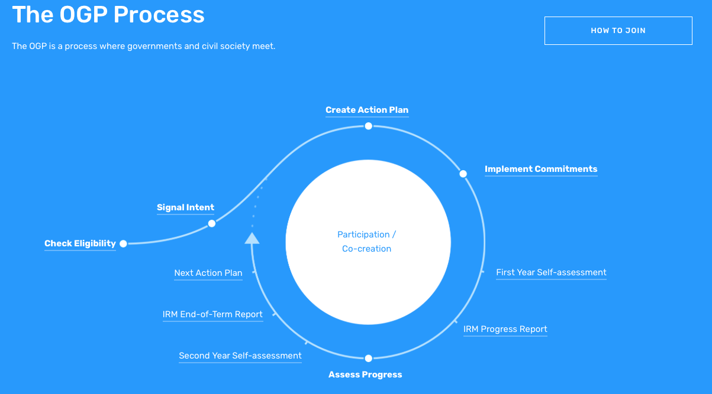

Potential Research Questions:

**State of the Evidence on the Impact of Open Government Reforms**

OGP acknowledges that in order to convince high-level political leaders to support open government reform efforts, there is a need to shift from normative arguments and demonstrate the positive, instrumental value of open government reforms. We would like to invest in better understanding the existing empirical and theoretical literature which identifies what is known about the impact of transparency, accountability and participation reforms, and their return on investment in terms of public trust, government efficiency, public accountability and development outcomes. Most importantly, we need to understand ways to use the evidence more effectively and incentivize high-level political leaders to champion open government. OGP invites researchers to investigate the following questions:

* Does involving citizens in policymaking and service delivery lead to improved trust and legitimacy between the state and society? How? Which OGP or non-OGP countries and subnational governments have demonstrated these outcomes?
* How does opening government lead to government efficiency and cost-savings? What evidence is there that government sectors and agencies which operate with the principles of open government perform better than those that don't?
* Does opening government lead to better investment climates and/or better economic growth? How have open government reforms helped the private sector to engage more effectively with government?
* What evidence is there that transparency, accountability and participation reforms have helped to identify, prevent or sanction corruption in government?

Data:

The data is collected from the Independent Reporting Mechanisms (IRP)